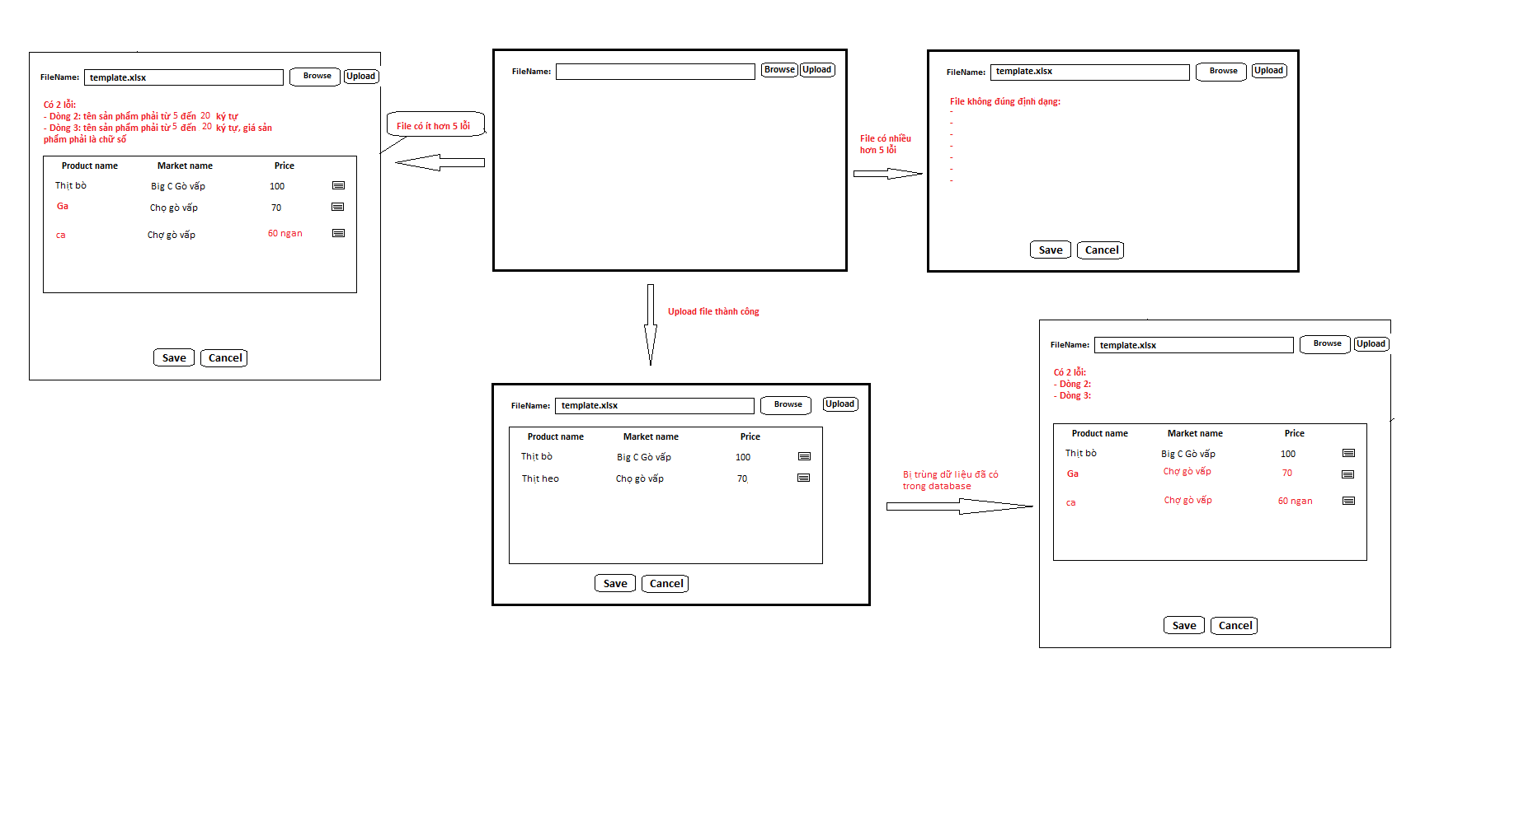

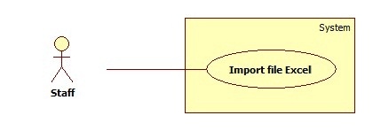

1. <Staff> Import Product

|  |  |  |  |  |
| --- | --- | --- | --- | --- |
| USE CASE–IMPORT PRODUCT | | | | |
| Use-case No. | UC001 | Use-case Version | | 2.0 |
| Use-case Name | Import file Excel | | | |
| Author | Tran Trung Dung | | | |
| Date | 14/01/2014 | Priority | High | |
| **Actor:** Staff  **Summary:** This use case allow staff to import data from excel file.  **Goal:** Create multiple products by importing from excel file.  **Triggers:**   * Staff wants to add new products by importing excel file. * Staff clicks **“Nhập từ excel”**.   **Pre**-**conditions**: User must log in to the system with role is staff.  **Post-conditions:**  **Success:** Products are added into database. Show success message.  **Fail:** Nothing is saved to the database. Display an error list.  **Main Success Scenario**   |  |  |  | | --- | --- | --- | | Step | Actor Action | System Response | | 1 | From the staff’s page, staff clicks “**Nhập từ Excel**” link. | * Show **“Nhập từ excel”** page with 2 buttons:   + “**Chọn file**” button.   + “**Tải lên**” button. | | 2 | From **“Nhập từ excel”** page, staff clicks “**Chọn file**” button, then clicks “**Mở**”. | System will get file path and show on text box. | | 3 | Staff click “**Tải lên**” button | * File is uploaded to server, then redirect back to **“Nhập từ excel”** page, contains:   + A 4-columns table show detail of product in excel file. Column header includes:     - “**Tên sản phẩm**” label.     - “**Tên chợ**” label.     - “**Giá**” label.     - Edit button.   + “**Lưu**” button.   + “**Hủy**” button.   [Exception 1, 2, 3, 4, 5] | | 5 | Staff clicks “**Lưu**” button to save product. [Alternative 1] | Save products into database. [Exception 6] |   **Alternative Scenario:**   |  |  |  | | --- | --- | --- | | Step | Actor Action | System Response | | 1 | Click on “**Hủy**” button to finish. | No product is added. System will return back to **“Nhập từ excel”** page. |   **Exceptions**   |  |  |  | | --- | --- | --- | | Step | Actor Action | System Response | | 1 | Product input is wrong format | Display error message: “**File không đúng định dạng**”. | | 2 | Product name is not in range [5, 20]. | Display error message: “**Tên sản phẩm phải từ 5 đến 20 ký tự**”. | | 3 | Market name is not in range [5, 20]. | Display error message: “**Tên chợ phải từ 5 đến 20 ký tự**”. | | 4 | Price is not a valid number. | Display error message: “**Giá sản phẩm phải là chữ số**”. | | 5 | Price is not in range [1, 5]. | Display error message: “**Giá sản phẩm phải từ 1 đến 5 chữ số**”. | | 6 | Fail to insert to database. | Display error message: “**Có lỗi xảy ra. Vui lòng thử lại sau.**”. |   **Relationships:** N/A  **Business Rules**:   * Valid file format (less than 5 errors): | | | | |

1. <Staff> Add new Product

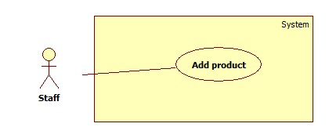

|  |  |  |  |  |
| --- | --- | --- | --- | --- |
| USE CASE–ADD PRODUCT | | | | |
| Use-case No. | UC002 | Use-case Version | | 2.0 |
| Use-case Name | Add product | | | |
| Author | Tran Trung Dung | | | |
| Date | 15/01/2014 | Priority | High | |
| **Actor:** Staff  **Summary:** This use case allows staff to add a new product in system.  **Goal:** Staff can add a new product includes: product name, market name, price or update price of product exist.  **Triggers:**  - Staff can create new product with all information: product name, market name, price  - To add new product, staff must do:   * On Home page, click on “**Quản lý sản phẩm**” in menu sidebar, then **Quản lý sản phẩm** page will be showed. *  Then, click on “**Thêm sản phẩm mới**” and add new product page will be showed. *  Then, staff input product’s information, then click “**Thêm sản phẩm**” button to finish.   **Pre**-**conditions**: User must log in to the system with role is staff.  **Post-conditions:**  **Success:** System will add product to database. The new product will be displayed on list product.  **Fail:** None of product is added to the system. Display errors in current page.  **Main Success Scenario**   |  |  |  | | --- | --- | --- | | Step | Actor Action | System Response | | 1 | Click “**Quản lý sản phẩm**” in menu bar. | Redirect to Product list page, contains:   * “**Thêm sản phẩm**” : link * A table product list: * “**Tên sản phẩm**”: label * “**Tên chợ**”: label * “**Giá**”: label * “**Kích hoạt**”/ “**Khóa**”: button. | | 1 | Click on “**Thêm sản phẩm**” on list product page. | System transfer to add new product page includes:  - **Tên sản phẩm**: textbox (min length: 5, max length: 20), required.  - **Tên chợ**: textbox (min length: 5, max length: 20), required.  - **Giá**: textbox (min length: 1, max length: 5), required.  - “**Thêm sản phẩm**” button  - “**Hủy**” button | | 2 | Enter information into text fields.  Click on “**Thêm sản phẩm**” button to finish. [Alternative 1] | System will add product to database.  A new product will be displayed in list product page. Then, transfer to list product page.[Exception 1, 2, 3] |   **Alternative Scenario:**   |  |  |  | | --- | --- | --- | | Step | Actor Action | System Response | | 1 | Click on “**Hủy**” button to finish. | No product is added. System will return back to list product page. |   **Exceptions**   |  |  |  | | --- | --- | --- | | Step | Actor Action | System Response | | 1 | Product name is not in range [5, 20]. | Display error message: “**Tên sản phẩm phải từ 5 đến 20 ký tự**”. | | 2 | Market name is not in range [5, 20]. | Display error message: “**Tên chợ phải từ 5 đến 20 ký tự**”. | | 3 | Price is not a valid number. | Display error message: “**Giá sản phẩm phải là chữ số**”. | | 4 | Price is not in range [1, 5]. | Display error message: “**Giá sản phẩm phải từ 1 đến 5 chữ số**”. |   **Relationships:** Search product  **Business Rules**:   * When staff enter product name, system will search all product name in database. * Staff can choose product exist and then update price of this product. | | | | |

1. **<Admin> Manage Account**

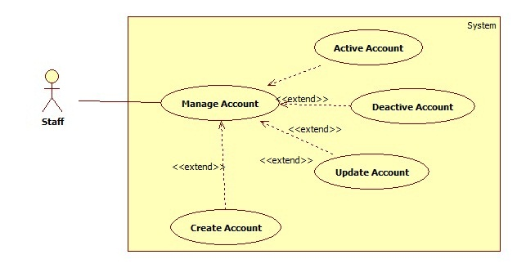

* 1. Create Account

|  |  |  |  |  |
| --- | --- | --- | --- | --- |
| USE CASE–UC003 | | | | |
| Use-case No. | UC003 | Use-case Version | | 2.0 |
| Use-case Name | Create Account | | | |
| Author | Tran Trung Dung | | | |
| Date | 15/01/2014 | Priority | High | |
| **Actor:** Staff  **Summary:** This user case allow staff to create an account for login the system  **Goal:** New account will be added to database.  **Triggers:**  - In our system, member can create new account. This function is used to create member account, in case of backup.  - To create a new account, staff must:   * User clicks “Tạo tài khoản mới” button. * Input new account information, click “Tạo tài khoản” to finish.   **Pre-conditions**:  - User must log in to the system with role is staff.  **Post-conditions**:  **Success:** New account is added to the system. Redirect to “Quản lý tài khoản” page.  **Fail:** No account created. Show error in current page.  **Main Success Scenario**   |  |  |  | | --- | --- | --- | | Step | Actor Action | System Response | | 1 | Staff clicks “Tạo tài khoản mới” link. | Redirect to “**Tạo tài khoản mới**” page. The page includes:   * Username: textbox, min length 6, max length 20, required. * Email: textbox (match regular expression:   ^([\w\.])+@([\w])+\.(\w){2,6}(\.([\w]){2,4})*$  , required).   * Password: password, min length 6, max length 20, required. * Password: password, min length 6, max length 20, required. * “Tạo tài khoản” button. * “Làm lại” button. | | 2 | Input new account information.  Staff clicks “**Tạo tài khoản**” button. [Alternative 1] | Insert new account to the database and redirect user to “**Quản lý tài khoản**” page.  [Exception 1, 2, 3,4,5,6] |   **Alternative Scenario**   |  |  |  | | --- | --- | --- | | No. | Actor Action | System Response | | 1 | Staff click “Làm lại” button. | Clear all textboxes value. |   **Exceptions**   |  |  |  | | --- | --- | --- | | No. | Actor Action | System Response | | 1 | Username already existed. | Show error “**Tên tài khoản đã được sử dụng**”. | | 2 | Username’s length is not in [6, 20] characters. | Show error “**Tên tài khoản phải từ 6 đến 20 ký tự**”. | | 3 | Password’s length is not in [6, 20] characters. | Show error “**Mật khẩu phải từ 6 đến 20 ký tự**”. | | 4 | Confirm password is not equal password | Show error “**Mật khẩu không trùng khớp**”. | | 5 | Email not matched regular expression. | Show error “**Email không đúng định dạng**”. | | 6 | Email already existed. | Show error “**Email đã được sử dụng**”. |   **Relationships:** Login, Manage Account  **Business Rules**:  - The “Nhập lại mật khẩu” value must match “Mật khẩu” value.  - Password is encoded by MD5 hash | | | | |

* 1. Update Account

|  |  |  |  |  |
| --- | --- | --- | --- | --- |
| USE CASE–UC004 | | | | |
| Use-case No. | UC004 | Use-case Version | | 2.0 |
| Use-case Name | Update Account | | | |
| Author | Tran Trung Dung | | | |
| Date | 14/01/2014 | Priority | High | |
| **Actor:** Staff  **Summary:** This use case allows staff to update account’s information.  **Goal:** Account’s information will be updated.  **Triggers:**  **-** In our system, member can update their account’s information. But in some case staff can update information account of member.  - To update account, staff must:   * User clicks “**Cập nhật tài khoản**” icon. * Change information, and then click “Cập nhật” to finish.   **Pre-conditions:**  - User must log in to the system with role is staff.  - User is at “**Quản lý tài khoản**” page.  **Post-conditions:**  **Success:** Account’s information is updated. Redirect to “**Quản lý tài khoản**” page.  **Fail:** Show error message.  **Main Success Scenario**   |  |  |  | | --- | --- | --- | | Step | Actor Action | System Response | | 1 | Staff click update icon | Redirect to “**Cập nhật tài khoản**” page. The page includes:   * Username: textbox, min length 6, max length 20, read only. * Email: textbox (match regular expression:   ^([\w\.])+@([\w])+\.(\w){2,6}(\.([\w]){2,4})*$  , required).   * “Cập nhật” button. * “Quay lại” button. | | 2 | Staff changes account’s information.  Staff clicks “**Cập nhật tài khoản**”. [Alternative1] | Update new account’s information to the database and show success message. [Exception 1, 2] |   **Alternative Scenario**:   |  |  |  | | --- | --- | --- | | Step | Actor Action | System Response | | 1 | Click on “**Quay lại**” button to finish. | No product is added. System will return back to “**Quản lý tài khoản**” page. |   **Exceptions**   |  |  |  | | --- | --- | --- | | No. | Actor Action | System Response | | 1 | Email already existed. | Show error “**Email đã được sử dụng**”. | | 2 | Email not matched regular expression. | Show error “**Email không đúng định dạng**”. |   **Relationships:** Manage Account  **Business Rules**: The “Nhập lại mật khẩu” value must match “Mật khẩu” value. | | | | |

* 1. Deactivate Account

|  |  |  |  |  |
| --- | --- | --- | --- | --- |
| USE CASE–UC005 | | | | |
| Use-case No. | UC005 | Use-case Version | | 2.0 |
| Use-case Name | Deactivate Account | | | |
| Author | Tran Trung Dung | | | |
| Date | 14/01/2014 | Priority | High | |
| **Actor:** Staff  **Summary:** This use case allows staff to Deactivate account from system.  **Goal:** Account’s user will be deactivated.  **Triggers:**  - In our system, when we do not want a user to login, we deactivate their account. The account can be activated later.  - On manage account page, staff click on “**Khóa tài khoản**” button  **Pre-conditions:**  - User must log in to the system with role is staff.  - There must be at least 1 active account in database.  **Post-conditions:**  **Success:** Account’s user is updated.  **Fail:** No account deactivated, show error message.  **Main Success Scenario**   |  |  |  | | --- | --- | --- | | Step | Actor Action | System Response | | 1 | Click “**Quản lý tài khoản**” in menu bar. | Redirect to “**Cập nhật tài khoản**” page. The page includes:  • Table with 5 column:  - Tên tài khoản: label  - Email: label  - Role: label  - Action: “**Kích hoạt**” and “**Khóa tài khoản**”.  - Update: icon  • Tạo tài khoản mới : button | | 2 | Staff clicks on “**khóa tài khoản**” button. | Account user is changed : Active to Deactivate |   **Alternative Scenario**: N/A  **Exceptions: N/A**  **Relationships:** Login, Manage Account  **Business Rules**: Staff can’t de-active account of themselves or other staff. | | | | |

* 1. Active Account

|  |  |  |  |  |
| --- | --- | --- | --- | --- |
| USE CASE–UC005 | | | | |
| Use-case No. | UC006 | Use-case Version | | 2.0 |
| Use-case Name | Active Account | | | |
| Author | Tran Trung Dung | | | |
| Date | 14/01/2014 | Priority | High | |
| **Actor:** Staff  **Summary:** This use case allows staff to Active account from system.  **Goal:** Account’s user will be activated.  **Triggers:**  - In our system, when user account was deactivated, we want to active their account. The account can be deactivated later.  - On manage account page, staff click on “**Kích hoạt**” button  **Pre-conditions:**  - User must log in to the system with role is staff.  - There must be at least 1 deactivate account in database.  **Post-conditions:**  **Success:** Account’s user is updated.  **Fail:** Show error message.  **Main Success Scenario**   |  |  |  | | --- | --- | --- | | Step | Actor Action | System Response | | 1 | Click “**Quản lý tài khoản**” in menu bar. | Redirect to “**Cập nhật tài khoản**” page. The page includes:  • Table with 5 column:  - Tên tài khoản: label  - Email: label  - Role: label  - Action: “**Kích hoạt**” and “**Khóa tài khoản**”.  - Update: icon  • Tạo tài khoản mới : button | | 2 | The, staff click on “**Kích hoạt**” button. | Account user is changed : Deactivate to Active |   **Alternative Scenario**: N/A  **Exceptions: N/A**  **Relationships:** Login, Manage Account  **Business Rules**: Staff can’t de-active account of themselves or other staff. | | | | |